**Step 1: create a free style project and gitve the name of project:**

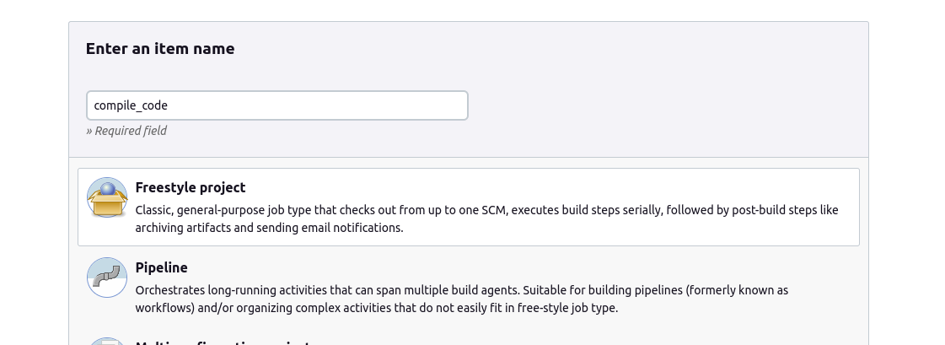

**Step 2: Add your private repository link and its credential like username and password as token.**

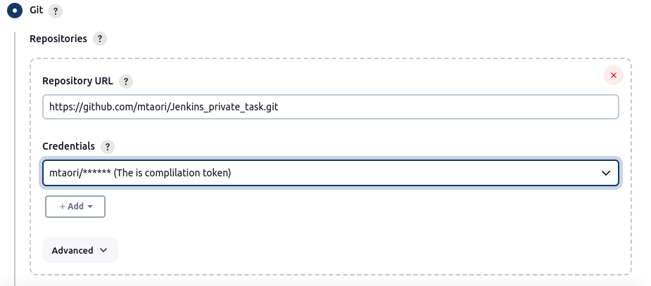

**Step 3: Add build steps as maven version and goals like: compile, test**

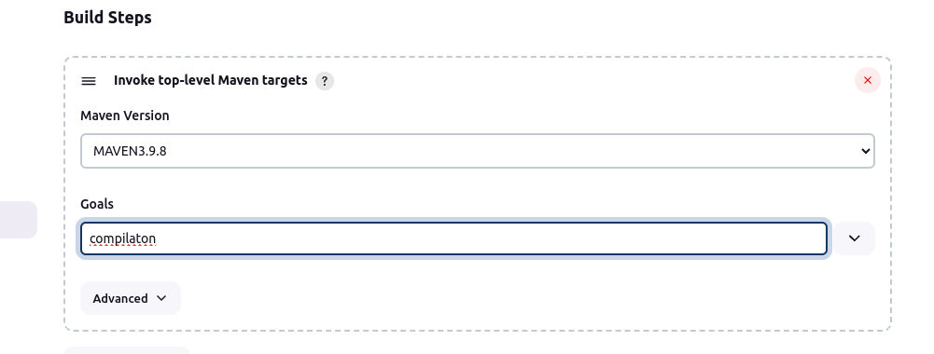

**Step 4: see the output in console output tab:**

